This WEEK News :

# Climate change caused mangrove collapse in Oman

# Most of the mangrove forests on the coasts of Oman disappeared.It indicates that the collapse of coastal ecosystems was caused by climatic changes.



# Native biodiversity collapse in the Eastern Mediterranean

# Global warming has led to an increase in sea temperatures beyond those temperatures that Mediterranean species can sustain. Consequently, many of them are going locally extinct.

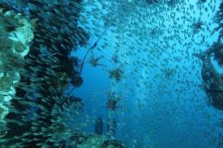

# 3. Discovery boosts theory that life on Earth arose from RNA-DNA mix



# 4. Catalyst transforms plastic waste to valuable ingredients at low temperature

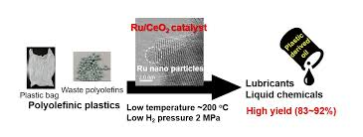

5. The record-breaking 2020 Antarctic ozone hole finally closed at the end of December after an exceptional season due to naturally occurring meteorological conditions

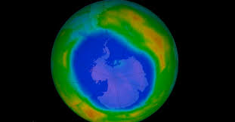

# 6. Spiders in space: Without gravity, light becomes key to orientation



# 7. Astronomers agree: Universe is nearly 14 billion years old

